PRODUCT DETAILS

**GMT-MASTER II**

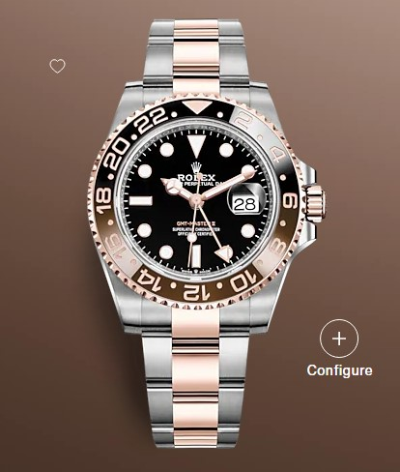

**$2800.00**

**Specifications**

**MODEL CASE**: Oyster, 40 mm, Oystersteel and Everose gold

**OYSTER ARCHITECTURE**: Monobloc middle case, screw-down case back and winding crown

**DIAMETER**: 40 mm

**MATERIAL**: Everose Rolesor - combination of Oystersteel and 18 ct Everose gold

**BEZEL**: Bidirectional rotatable 24-hour graduated bezel. Two-colour brown and black Cerachrom insert in ceramic, moulded numerals and graduations

**WINDING CROWN**: Screw-down, Triplock triple waterproofness system

**CRYSTAL**: Scratch-resistant sapphire, Cyclops lens over the date

**WATER RESISTANCE**: Waterproof to 100 metres / 330 feet

**MOVEMENT**: Perpetual, mechanical, self-winding, GMT function

**CALIBRE**: 3285, Manufacture Rolex

**PRECISION**: -2/+2 sec/day, after casing

**FUNCTIONS**: Centre hour, minute and seconds hands. 24-hour display. Second time zone with independent rapid-setting of the hour hand. Instantaneous date. Stop-seconds for precise time setting

**WINDING**: Bidirectional self-winding via Perpetual rotor

**POWER RESERVE**: Approximately 70 hours

**BRACELET**: Oyster, flat three-piece links

**BRACELET MATERIAL**: Everose Rolesor - combination of Oystersteel and 18 ct Everose gold

**CLASP**: Folding Oysterlock safety clasp with Easylink 5 mm comfort extension link